**Exercise 2**

**Task 1**

Create files named index.html and styles.css. Link the CSS file to the HTML document.

In the HTML document, using appropriate tags, create the following content (the text is appended at the end of the document).

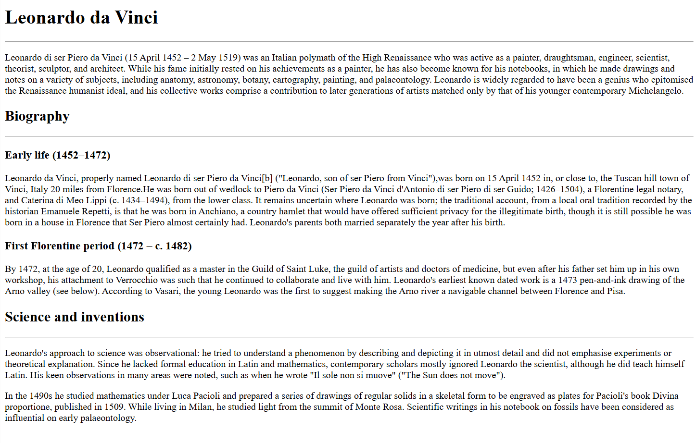

Apply the following styling (you can modify the provided colors as desired):

1. Set the body of the document to a beige background, text color: chocolate.
2. Select the first-level heading (Leonardo da Vinci) and set its text color to brown. The text should be bold. Font size – 24px.
3. The second-level heading should be bold and centered. Font size – 22px.
4. The third-level heading should be bold and italic. Font size – 20px.
5. The paragraphs in the text should be jusified, 16px.
6. Create a class “text-center”, by setting its property the text to be centered. Apply to the first-level and third-level headings.
7. Create a class “text-left”, by setting its property to text to be aligned to the left. Apply to the second-level heading. What will be the alignment of the heading after adding the class – centered or left? Check in VS Code the specificity of the two selectors.
8. Create a class “highlight”, setting the background color to gold and the text color to darkgreen. Apply it to the first paragraph and to the section formed by the second third-level heading and the text below it.
9. Surround the text “Leonardo di ser Piero da Vinci ("Leonardo, son of ser Piero from Vinci")” with an inline container (span), to which you assign a unique identifier “person-name”. Select by id and set bold and text color to crimson.
10. Select only the horizontal lines that are after the second-level headings. Set them to a height of 2px (height: 2px;) and a background color - crimson. What is the specificity of the selector used?

Result:

**Task 2**

Create files named index.html and styles.css. Link the CSS file to the HTML document.

Create and style the document, the view of which is shown below (the text is appended at the end of the document). You can choose between different selectors, but let there be at least one selector by tag, at least one by class and at least one by id. Select color combinations by your choice.

**Text for task 1**

Leonardo da Vinci

Leonardo di ser Piero da Vinci (15 April 1452 – 2 May 1519) was an Italian polymath of the High Renaissance who was active as a painter, draughtsman, engineer, scientist, theorist, sculptor, and architect. While his fame initially rested on his achievements as a painter, he has also become known for his notebooks, in which he made drawings and notes on a variety of subjects, including anatomy, astronomy, botany, cartography, painting, and palaeontology. Leonardo is widely regarded to have been a genius who epitomised the Renaissance humanist ideal, and his collective works comprise a contribution to later generations of artists matched only by that of his younger contemporary Michelangelo.

Biography

Early life (1452–1472)

Leonardo da Vinci, properly named Leonardo di ser Piero da Vinci ("Leonardo, son of ser Piero from Vinci"), was born on 15 April 1452 in, or close to, the Tuscan hill town of Vinci, Italy 20 miles from Florence. He was born out of wedlock to Piero da Vinci (Ser Piero da Vinci d'Antonio di ser Piero di ser Guido; 1426–1504), a Florentine legal notary, and Caterina di Meo Lippi (c. 1434–1494), from the lower class. It remains uncertain where Leonardo was born; the traditional account, from a local oral tradition recorded by the historian Emanuele Repetti, is that he was born in Anchiano, a country hamlet that would have offered sufficient privacy for the illegitimate birth, though it is still possible he was born in a house in Florence that Ser Piero almost certainly had. Leonardo's parents both married separately the year after his birth.

First Florentine period (1472 – c. 1482)

By 1472, at the age of 20, Leonardo qualified as a master in the Guild of Saint Luke, the guild of artists and doctors of medicine, but even after his father set him up in his own workshop, his attachment to Verrocchio was such that he continued to collaborate and live with him. Leonardo's earliest known dated work is a 1473 pen-and-ink drawing of the Arno valley (see below). According to Vasari, the young Leonardo was the first to suggest making the Arno river a navigable channel between Florence and Pisa.

Science and inventions

Leonardo's approach to science was observational: he tried to understand a phenomenon by describing and depicting it in utmost detail and did not emphasise experiments or theoretical explanation. Since he lacked formal education in Latin and mathematics, contemporary scholars mostly ignored Leonardo the scientist, although he did teach himself Latin. His keen observations in many areas were noted, such as when he wrote "Il sole non si muove" ("The Sun does not move").

In the 1490s he studied mathematics under Luca Pacioli and prepared a series of drawings of regular solids in a skeletal form to be engraved as plates for Pacioli's book Divina proportione, published in 1509. While living in Milan, he studied light from the summit of Monte Rosa. Scientific writings in his notebook on fossils have been considered as influential on early palaeontology.

**Text for task 2**

Tron

Cast

The list of the main characters is included only.

Jeff Bridges as Kevin Flynn, a former ENCOM programmer and video game developer who runs an arcade following his termination from the company. He is beamed into the mainframe via a digitizing laser by the MasterControl Program. Bridges also portrays Clu (Codified Likeness Utility), a hacking program developed by Flynn to find evidence of Dillinger's theft in the mainframe.

Bruce Boxleitner as Alan Bradley, Flynn's work partner and fellow ENCOM programmer. Boxleitner also portrays Tron, a security program developed by Alan to self-monitor communications between the MCP and the real world.

David Warner as Ed Dillinger, the senior executive vice president of ENCOM. He was once a coworker of Flynn who used the Master Control Program to steal the latter's work and pass it off as his own, earning himself a series of undeserved promotions.

Warner also portrays Sark, a command program developed by Dillinger to serve as the MCP's second-in-command. Warner additionally provided the uncredited voice of the Master Control Program (MCP), a rogue artificial intelligence operating system that originated as a chess program created by Dr. Walter Gibbs but annexed by Dillinger for his own use. The MCP monitors and controls ENCOM's mainframe.

Cindy Morgan as Dr. Lora Baines, Alan's coworker and girlfriend. She and Gibbs collaborate on  ENCOM's digitization experiment. Morgan also portrays Yori, an input/output program developed by Lora and an ally of Tron. Barnard Hughes as Dr. Walter Gibbs, a co-founder of ENCOM who runs the company's science division. He creates the SHV 20905 digitizing laser with Lora's assistance.

Hughes also plays Dumont, a guardian program developed by Gibbs to protect input/output junctions in the mainframe. Hughes was also the MCP's physical form, which was shown just before it died.

Dan Shor as Ram, an actuarial program who is a close ally of Tron and Flynn. Shor also briefly appears as an ENCOM programmer credited as "Popcorn Co-Worker".

Peter Jurasik as Crom, a compound interest program matched against Flynn on the Game Grid.

Tony Stephano as Peter, Dillinger's assistant. Stephano additionally played Sark's Lieutenant.

Soundtrack

The soundtrack hit all the charts in USA and Europe.

The soundtrack for Tron was written by pioneer electronic musician Wendy Carlos, who is best known for her album Switched-On Bach and for the soundtracks to many films, including the Stanley Kubrick-directed films A Clockwork Orange and The Shining. The music, which was the first collaboration between Carlos and her partner Annemarie Franklin, featured a mix of an analog Moog synthesizer and Crumar's GDS digital synthesizer (complex additive

and phase modulation synthesis), along with non-electronic pieces performed by the London Philharmonic Orchestra (hired at the insistence of Disney, which was concerned that Carlos might not be able to complete her score on time).

Two additional musical tracks ("1990's Theme" and "Only Solutions") were provided by the American band Journey after British band Supertramp pulled out of the project. An album featuring dialogue, music and  sound effects from the film was also released on LP by Disneyland Records in 1982.